**Year 9 Term 4 – Body Systems. Revision SHEET No. 2**

**Learning Goal 6:** Understand that the coordination of all body systems is carried out by the Nervous and Endocrine systems.

1. Use the following diagram to help you match the word to its meaning in the table below:



Axon

Myelin

Dendrites

|  |  |
| --- | --- |
| Word | Meaning |
| neurotransmitter | The branches on the nucleus end of a neuron |
| neurons | The gap between two nerve cells |
| axon | An electrochemical signal that travels along a nerve cell |
| Nerve impulse | The main bundle of nerve fibres that leaves the brain |
| myelin | Nerve cell |
| synapse | A chemical that makes the connection between across the gap between two neurons. |
| dendrite | A type of nerve signal that does not require input from the brain |
| reflex | A nerve fibre |
| spinal cord | The organ that controls the nervous system |
| brain | A fatty coating around the axon which acts like insulation. |

1. Match the gland in column A, with the hormone it produces in Column B, and with the main effect in column C.

|  |  |  |
| --- | --- | --- |
| **Column A** | **Column B** | **Column C** |
| Adrenal Gland | Testosterone | Helps control high blood sugar levels. |
| Testes | Adrenaline | Stimulates cell growth and replication. |
| Ovaries | Insulin | Prepares the body for fight or flight. |
| Pituitary Gland | Oestrogen | Sperm production and secondary male characteristics. |
| Pancreas | Growth Hormone | Egg production and secondary female characteristics. |

1. Use the following diagram to explain how the pancreas and liver work together to maintain healthy glucose levels in the body.

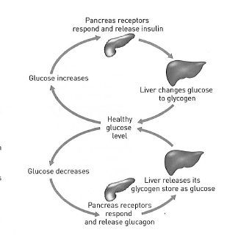

1. The following table shows the blood glucose levels of two people after consuming 50 g of glucose in a can of drink:

|  |  |  |
| --- | --- | --- |
| **Time after drinking a can of fruit juice (minutes)** | **Blood glucose level (mg/100 ml)** | |
| **Bill** | **Dianne** |
| 0 | 86 | 85 |
| 15 | 110 | 125 |
| 30 | 140 | 170 |
| 45 | 115 | 190 |
| 60 | 90 | 210 |
| 75 | 80 | 210 |
| 90 | 84 | 200 |
| 105 | 85 | 180 |
| 120 | 85 | 145 |

1. Which person suffers from diabetes?
2. Rapid-acting insulin can begin working within 1 hour. At what time should the diabetic person have taken the injection?
3. What causes the non-diabetic person’s blood glucose levels to fall?

1. Why did the diabetic person’s blood glucose level eventually fall?

1. The human body’s source of energy is the process of cellular respiration. This process is essentially a chemical reaction between glucose and oxygen. The chemical reaction produces carbon dioxide and water, and also releases a considerable amount of energy and heat that is used within the cells of the body. The chemical reaction for cellular respiration is shown below

C6H12O6 + O2 → CO2 + H2O + heat/energy

*Glucose Oxygen Carbon dioxide water*

For this reaction to occur in each cell, the body must have a way of supplying each body with the necessary glucose and oxygen, and a way of getting rid of the carbon dioxide and water.

Answer the following questions about these processes.

1. Explain how the digestive system and circulatory system combine to supply the cells with glucose.

|  |
| --- |
|  |
|  |
|  |
|  |

1. Explain how the respiratory system and circulatory system combine to supply the cells with oxygen.

|  |
| --- |
|  |
|  |
|  |
|  |

1. Explain how the circulatory system and the respiratory system combine to excrete carbon dioxide from the body.

|  |
| --- |
|  |
|  |
|  |
|  |

1. Explain how the excretory system and circulatory system combine to regulate (control) the amount of water in the body.

|  |
| --- |
|  |
|  |
|  |
|  |

1. Label the following diagram of the brain and describe the main function of each.

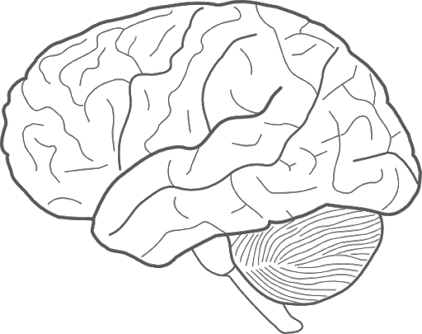

A

B

C

Main Functions:

|  |
| --- |
| **A** |
| **B** |
| **C** |

1. Complete the following table showing similarities and differences between the nervous system and the endocrine system

|  |  |  |
| --- | --- | --- |
|  | NERVOUS SYSTEM | ENDOCRINE SYSTEM |
| What is the main function? |  |  |
| What type of signal is sent by the system? |  |  |
| How does the signal travel through the body? |  |  |
| How fast does the signal travel? |  |  |
| How long does the action last for? |  |  |

**Learning Goal 6:** Understand the immune system protects the body from pathogens and their toxins.

1. Match each of the following words to their meaning:

|  |  |
| --- | --- |
| **Word** | **Meaning** |
| Pathogen | Can only reproduce inside host cells and are responsible for colds, flu, measles and many more diseases. |
| Virus | Can attack and engulf foreign particles. |
| Bacteria | Can be activated if a pathogen enters a cut in your skin. |
| White Blood Cells | Examples are: sneezing, coughing and eating contaminated food. |
| Disease Transmission | Anything that can cause a disease. |
| Inflammatory Response | Able to reproduce without invading a host cell. They release a variety of toxins some of which are harmful to humans. They can be killed by antibiotics. |

1. Describe each of the three levels of immune system defence

|  |
| --- |
|  |
|  |
|  |
|  |
|  |
|  |

1. The immune system does not “attack” every virus or bacteria which enters, or is in your body. Is this a bad thing? Explain your answer.

|  |
| --- |
|  |
|  |
|  |

